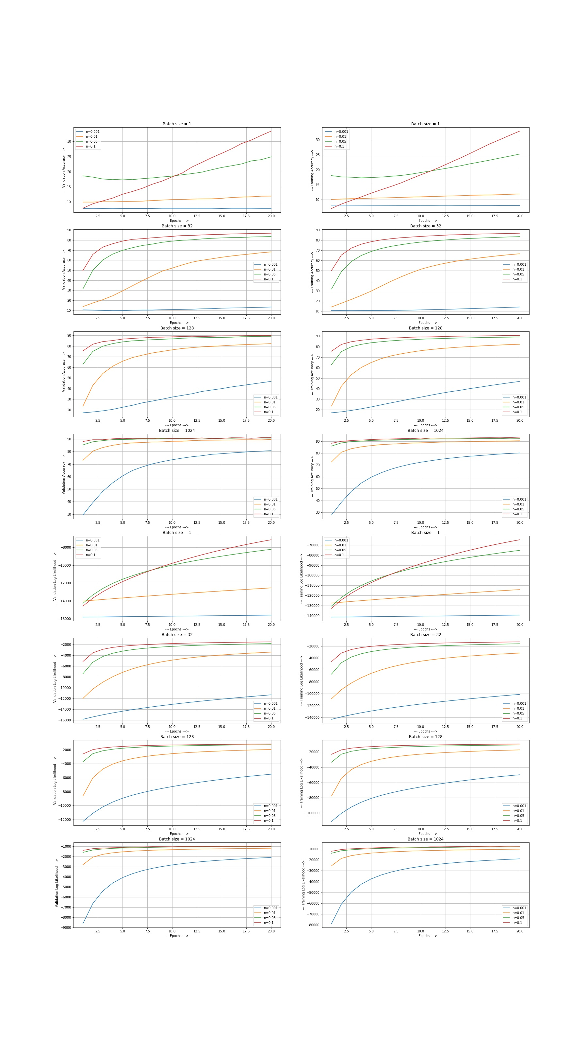

----------For Batch Size = 1, Learning Rate = 0.001----------

EPOCH: [===================>] 100%

Testing Accuracy is : 14.607142857142858%

----------For Batch Size = 1, Learning Rate = 0.01----------

EPOCH: [===================>] 100%

Testing Accuracy is : 11.30952380952381%

----------For Batch Size = 1, Learning Rate = 0.05----------

EPOCH: [===================>] 100%

Testing Accuracy is : 25.738095238095237%

----------For Batch Size = 1, Learning Rate = 0.1----------

EPOCH: [===================>] 100%

Testing Accuracy is : 31.202380952380953%

----------For Batch Size = 32, Learning Rate = 0.001----------

EPOCH: [===================>] 100%

Testing Accuracy is : 14.214285714285715%

----------For Batch Size = 32, Learning Rate = 0.01----------

EPOCH: [===================>] 100%

Testing Accuracy is : 67.04761904761905%

----------For Batch Size = 32, Learning Rate = 0.05----------

EPOCH: [===================>] 100%

Testing Accuracy is : 84.48809523809524%

----------For Batch Size = 32, Learning Rate = 0.1----------

EPOCH: [===================>] 100%

Testing Accuracy is : 87.52380952380953%

----------For Batch Size = 128, Learning Rate = 0.001----------

EPOCH: [===================>] 100%

Testing Accuracy is : 38.345238095238095%

----------For Batch Size = 128, Learning Rate = 0.01----------

EPOCH: [===================>] 100%

Testing Accuracy is : 82.70238095238095%

----------For Batch Size = 128, Learning Rate = 0.05----------

EPOCH: [===================>] 100%

Testing Accuracy is : 88.80952380952381%

----------For Batch Size = 128, Learning Rate = 0.1----------

EPOCH: [===================>] 100%

Testing Accuracy is : 90.60714285714285%

----------For Batch Size = 1024, Learning Rate = 0.001----------

EPOCH: [===================>] 100%

Testing Accuracy is : 81.55952380952381%

----------For Batch Size = 1024, Learning Rate = 0.01----------

EPOCH: [===================>] 100%

Testing Accuracy is : 89.78571428571429%

----------For Batch Size = 1024, Learning Rate = 0.05----------

EPOCH: [===================>] 100%

Testing Accuracy is : 91.67857142857143%

----------For Batch Size = 1024, Learning Rate = 0.1----------

EPOCH: [===================>] 100%

Testing Accuracy is : 91.82142857142857%

We see that more time we give to the model to train, better is the Accuracy. Specific Observation is as below:

1. **Batch Size Vs Accuracy**: More batch size means more iterations. We observed that as we increase the batch size, the accuracy increases and stabilizes around 90 %. Both validation and training accuracy increased indicating that the model didn’t overfit.
2. **Epoch Vs Accuracy**: We can see that as the no of epochs increased, the accuracy for both training and validation has increased and has come to saturation after some epochs. To save computational effort, we should regulate this growth and stop the training when the difference between the accuracy of last two epoch isn’t significant enough.
3. **Learning Rate vs Accuracy**:
4. N=0.01: When the learning rate was this small, it took time to gain significant accuracy. That’s why we see that training and validation accuracy is bit low in this case as compared to others. Its not saturated till 20 epochs.
5. N= 0.1: Being the greatest among all other, the model learned very quickly. We can also see that at batch size 1024, the validation accuracy reached around 85% after one epoch only, while the one with learning rate 0.01 is at 72% and the one with 0.001 is around 30%.